 | 20.1.1 Editors - NLA Editor - Header tools and options
Table of content
Introduction 1
Header Tabs 2
Tweak Mode 2
Tweak 2
Isolate 2
Show Hide elements 3
Only Show Selected 3
Show Hidden 3
Include Missing NLA 3
Filters 3
Filter by Collection 3
Filter by Type 3
Options 3
Sort Data Blocks 3
Snapping Panel 3
Toggle Snapping On/Off 4
Frame 4
Second 4
Nearest Market 4
Absolute Time Snap 4
Playhead Snapping 4
Toggle Playhead Snapping On/Off 4
Distance 5
Snap Target 5
Frames 5
Seconds 5
Markers 5
Keyframes 5
Strips 5
Frame Step 5
Second Step 5
Options 5
Real-time Updates 6
Show Seconds 6
Sync visible range 6
Show Control F-Curves 6
Show Markers 6
Show Local Markers 6
Lock Markers 6

Introduction

The header contains various menus and tools. This chapter here is about the tools, modes and options elements in the header.

The text menus are covered in an own chapter each.

Header Tabs

The tabs at the very left allows you to switch between the four most important editor types by one click. Dope sheet Editor, Graph Editor, Driver Editor, NLA Editor.

Tweak Mode

Tweak
The tweak mode allows you to edit the keyframe data within an Action clip while evaluating the full stack. The strip will turn green and in the Dope Sheet editor you will find the Action clip’s keyframes, which you can now tweak.
Playback will show a blend of all NLA tracks while you edit the Action clip.
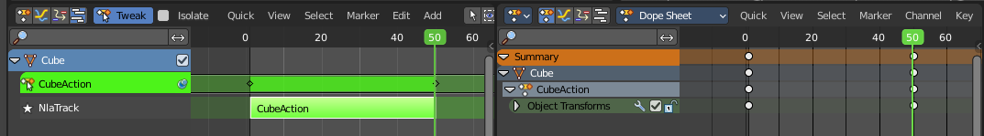

Isolate
Tweak with the Isolate checkbox on allows editing of the animation data on only the selected and isolated Action Clip.
Playback will show only the keyframes of of the isolated Action clip.
Note: You can also isolate a clip by clicking on the star icon at the left.
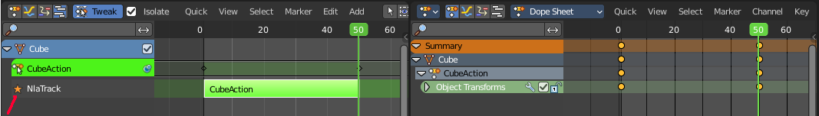
There are similar Tweak mode tool in the Edit menu too where you can edit with the full stack, lower stack or isolated Action clips. Leaving the Tweak mode is for the first two methods evaluated in the header.

Show Hide elements

Only Show Selected
Display only the data for the selected object in the list of elements. If off it displays all available animation data of the whole scene.

Show Hidden
Include channels from objects / bones that are not visible. This feature just works with Only Selected off.

Include Missing NLA
Include Animation data blocks without NLA data.

Filters

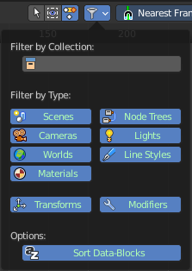
The show hide elements allows you to filter out the general elements. The Filters panel allows you to filter out further elements.

Filter by Collection
Just display the content from the chosen collection in the list of elements.

Filter by Type
In this section you can choose what type of animation data should be displayed. The names should be self explaining.

Options

Sort Data Blocks
Alphabetically sort the data in the list of elements.

Snapping Panel
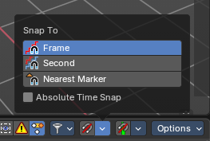
Snapping in animation editors helps align the playhead and keyframes to meaningful time-based elements, improving precision and workflow efficiency across the Timeline, Dope Sheet, Graph Editor, NLA, and Video Sequencer.
Note: This sub-subpanel is not available for Grease Pencil Dopesheet Mode

Toggle Snapping On/Off
Toggles the snapping on or off with a visual indicator.

Frame
Snaps to whole frame numbers. Ideal for frame-accurate editing instead of sub-frame timeline cursor placement.

Second
Snaps to time intervals measured in seconds. Useful for audio syncing or time-based pacing.

Nearest Market
Snaps to the closest timeline marker. Great for aligning actions to scene events or beats.

Absolute Time Snap
When enabled, snapping uses absolute time rather than relative pixel proximity. Ensures consistent snapping behavior regardless of zoom level or cursor position.

Playhead Snapping

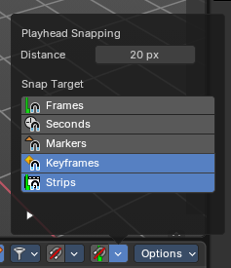
Playhead controls in animation editors help position the current frame indicator with precision, improving navigation and editing across the Timeline, Dope Sheet, Graph Editor, NLA, and Video Sequencer.

Toggle Playhead Snapping On/Off
Toggles snapping behavior for the playhead with a visual indicator. When enabled, the playhead will snap to nearby time-based targets during scrubbing or dragging.
Tip: You can temporarily enable/disable the playhead snapping by holding down CTRL while dragging the playhead.

Distance
Sets the snapping threshold in pixels. Determines how close the playhead must be to a target for snapping to occur.

Snap Target

Frames
Snaps to whole frame numbers. Ideal for frame-accurate editing instead of sub-frame cursor placement.

Seconds
Snaps to time intervals measured in seconds. Useful for audio syncing or time-based pacing.

Markers
Snaps to the closest timeline marker. Great for aligning actions to scene events or beats.

Keyframes
Snaps to keyframe positions. Ensures precise alignment for editing and playback.

Strips
Snaps to the start or end of video/audio strips. Useful in the Video Sequencer and NLA editor.

Frame Step
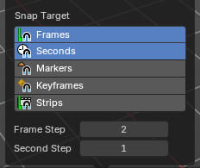
Defines the step size for frame-by-frame navigation. Controls how far the playhead moves when stepping through frames manually.
Note: Only available with Frames Snap Target

Second Step
Defines the step size for second-by-second navigation. Controls how far the playhead moves when stepping through the timeline manually.
Note: Only available with Second Snap Target

Options
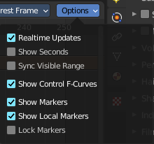

Real-time Updates
When transforming keyframes then this transformation is also immediately visible in other editors.

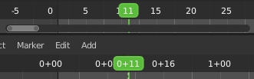
Show Seconds
Show the timing in the timeline area in seconds instead of frames.

Sync visible range
Synchronize the visible timeline range with other visible time based editors. When you zoom in or out in the one editor, then it zooms in or out in the other editor too. Each editor to sync needs to have Sync Visible Range ticked.

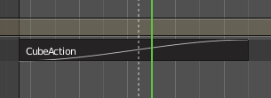
Show Control F-Curves
Shows existing f-curves in the action strip. Like for keyframed Animated influence.

Show Markers
Display the markers.

Show Local Markers
Show action-local markers on the strips.

Lock Markers
Make the markers uneditable.

